Chapter 4, Problem 66.

Find the maximum power that can be delivered to the resistor R in the circuit in Fig. 4.132.

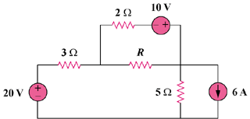

Figure 4.132
For Prob. 4.66.

